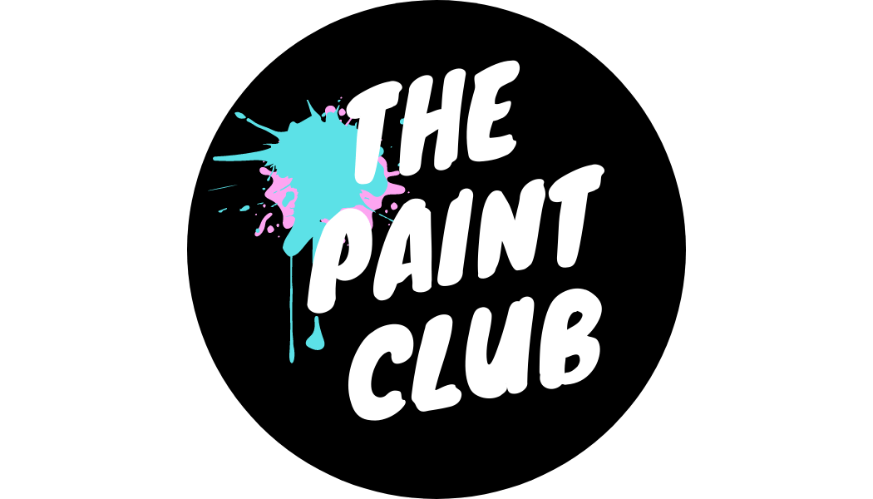

Artist for The Paint Club
*Part time job opportunity*

The Paint Club is a fun, creative, and friendly small business. Our events are not your usual art class! You may have heard of ‘paint and sip’, which is a good way of describing what happens at our events. Our customers come for a night out with friends whilst painting something enjoyable and easy.

As an artist for The Paint Club, you’d be taking complete beginners through step-by-step from blank canvas to work of art.

We’ve found it's the perfect way to unwind, get creative and try something new. Drink in one hand, paint brush in the other.

We are looking for artists to join our team to run events based in and around:
- Leicestershire
- Derbyshire
- South Yorkshire (Sheffield)
- Staffordshire
- Shropshire (Shrewsbury and Telford specifically)
- Edinburgh
- Wiltshire
- Bath
- Bristol
- Somerset
- Exeter
- North Wales

Please note we are not recruiting outside of the areas listed above at the moment.

Events are held on regular days every month, along with one off events for businesses and private groups.

We are looking for someone who is confident leading a large group of people; Who is an experienced, or practising artist, and preferably has experience teaching or presenting to groups;
The ideal candidate must be a good communicator and enjoy being around groups of people. They will be pragmatic, good at problem solving, honest and reliable.

You would need your own transport and somewhere to store equipment which takes up the equivalent of a large suitcase. We use acrylic paint on canvas for our workshops. Artists are not required to design the paintings, The Paint Club will provide the topic and guidance on how to paint them.

Please note the majority of events are late afternoon or evening. We occasionally do day time events too but these may be at the weekend. Please consider this when applying.
Details:
-Flexible part time creative event work
-Relevant artistic experience is essential.
-Confident leading groups of people
-Own transport required

If you would like to apply please send your CV, along with a short video telling us about yourself, why you would like to apply for the role and a short clip of you leading us through a painting, to hello@thepaintclub.co.uk

You can find some video suggestions on our facebook page (https://www.facebook.com/thepaintclub.uk/videos) if you are not sure what to paint. The video only needs to be a few minutes long, just a few snapshots of your painting process.

